SI3PSI – Team Terminal

DATABASE SPECIFICATION
FOR GoldenView PROJECT

Version V 1.0
Date: 19. 04.2023.

Revision history

Revision | Datum | Author | Description
Version v1.0 | 19.04.2023. | Jovan Jovanovic  Jovana Bjelica
Version v1.1 | 21.04.2023. | Jovan Jovanovic  Jovana Bjelica  Aleksandar Radenkovic | No tables across 2 pages.  Fixed typos.
Version v2.0 | 16.06.2023. | Jovan Jovanovic  Jovana Bjelica  Aleksandar Radenkovic | Removed PasswordChangeRequest table. Updated NoSQL tables examples’ explanations.
Version v3.0 | 03.10.2023. | Jovan Jovanovic  Jovana Bjelica  Aleksandar Radenkovic | Split NoSQL carried_out_trade_request into 2 tables, 1 each for carried out purchase and sales requests. Left only specializations of ActiveTradeRrequest. Removed IsBoundByContract table.

Content
1. Introduction 5
1.1 Purpose 5
1.2 Target groups 5
1.3 Document organization 5
1.4 Glossary of terms and abbreviations 5
1.5 Open questions 5
2. Database model 6
2.1 IE notation diagram 6
2.2 Relation database schema 7
3. Tabels 8
3.1 User 8
3.2 UsersGroup 8
3.3 Role 8
3.4 HasRole 8
3.5 Administrator 9
3.6 Trader 9
3.7 BasicUser 9
3.8 Broker 10
3.9 BrokerRequest 10
3.11 TextFile 10
3.12 BrokerRequestFile 10
3.13 ApprovalReportFile 10
3.14 BrokerBasicUserContractFile 11
3.15 BrokerBasicUserContract 11
3.16 Country 11
3.17 FundsTransferMethod 11
3.18 MakeBeliefOwns 12
3.19 Asset 12
3.20 PurchaseRequest 12
3.21 SalesRequest 13
3.22 carried_out_purchase_request 14
3.23 carried_out_sales_request 15
3.24 asset_transaction 16
3.25 asset_stats 17
3.26 contact_support_request 18

1. Introduction

1.1 Purpose

The database for the project from the course Principles of Software Engineering is a flexible and reliable way of storing data and accessing it by a web server to generate web pages.
The document includes a diagram (data model) with IE (Information Engineering) notation, a scheme of the relational database, as well as a description of all the tables in the database.
This document serves as the basis for the development of the detailed design specification of the observed subsystem, implementation and testing. All data that needs to be stored is obtained in the phase of analyzing user requests.

1.2 Target groups
The document is intended for the team leader of the project and members of the development team.
This document serves the team leader to plan development activities and specify table names and field names in the database, so that independent units, implemented by different parts of the development team, are successfully integrated at the end of the work.
The development team uses the document as a basis for design and implementation.

1.3 Document organization
The rest of the document is organized into the following chapters:
- Data model - database model and database schema;
- Tabels;

1.4 Glossary of terms and abbreviations

- IE – Information Engineering, database modeling notation;

1.5 Open questions

Number | Date | Problem | Solution

2. Database model

2.1 IE notation diagram

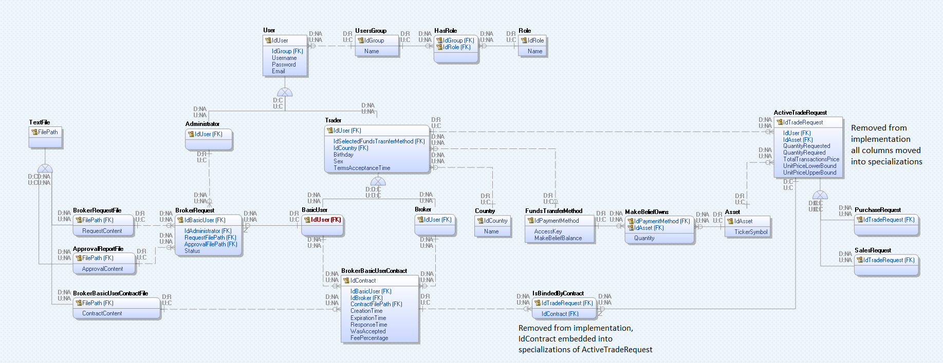

2.2 Relation database schema

User (IdUser, IdGroup, Username, Password, Email)
UsersGroup (IdGroup, Name)
Role (IdRole, Name)
HasRole (IdGroup, IdRole)
Administrator (IdUser)
Trader (
IdUser, IdSelectedFundsTransferMethod, IdCountry, Birthday, Sex, TermsAcceptanceTime
)
BasicUser (IdUser)
Broker (IdUser)
BrokerRequest (
IdBasicUser, IdAdministrator, RequestFilePath, ApprovalFilePath, Status
)
TextFile (FilePath)
BrokerRequestFile (FilePath, RequestContent)
ApprovalReportFile (FilePath, ApprovalContent)
BrokerBasicUserContractFile (FilePath, ContractContent)
BrokerBasicUserContract (
IdContract, IdBasicUser, IdBroker, ContractFilePath, CreationTime, ExpirationTime, ResponseTime, WasAccepted, FeePercentage
)
Country (IdCountry, Name)
FundsTransferMethod (IdPaymentMethod, AccessKey, MakeBeliefBalance)
MakeBeliefOwns (IdPaymentMethod, IdAsset, Quantity)
Asset (IdAsset, TickerSymbol)
PurchaseRequest (
IdPurchaseRequest, IdUser, IdAsset, QuantityRequested, QuantityRequired, TotalTransactionsPrice, UnitPriceLowerBound, UnitPriceUpperBound,
IsBoundByContract, IdContract
)
SalesRequest (
IdSalesRequest, IdUser, IdAsset, QuantityRequested, QuantityRequired, TotalTransactionsPrice, UnitPriceLowerBound, UnitPriceUpperBound,
IsBoundByContract, IdContract
)

3. Tabels

3.1 User
Contains information about users of the application.

Name | Datatype | Is PK | Is FK
IdUser | Integer | Yes | No
IdGroup | Integer | No | Yes
Username | Varchar(32) | No | No
Password | Varchar(128) | No | No
Email | Varchar(64) | No | No

3.2 UsersGroup
Contains information about user groups in the application.

Name | Datatype | Is PK | Is FK
IdGroup | Integer | Yes | No
Name | Varchar(18) | No | No

3.3 Role
Contains information about roles in the application.

Name | Datatype | Is PK | Is FK
IdRole | Integer | Yes | No
Name | Varchar(18) | No | No

HasRole
Contains ordered pairs of user groups and roles assigned to them.

Name | Datatype | Is PK | Is FK
IdGroup | Integer | Yes | Yes
IdRole | integer | Yes | Yes

Administrator
Contains information about administrators in the application.

Name | Datatype | Is PK | Is FK
IdUser | Integer | Yes | yes

Trader
Contains information about traders in the application.

Name | Datatype | Is PK | Is FK
IdUser | Integer | Yes | Yes
IdSelectedFundsTransferMethod | Integer | No | Yes
IdCountry | Integer | No | Yes
Birthday | Date | No | No
Sex | Varchar(6) | No | No
TermsAcceptanceTime | Date | No | No

BasicUser
Contains information about basic users in the application.

Name | Datatype | Is PK | Is FK
IdUser | Integer | Yes | Yes

Broker
Contains information about brokers in the application.

Name | Datatype | Is PK | Is FK
IdUser | Integer | Yes | Yes

BrokerRequest
It contains information about users who submitted a request to become a Broker, which of the administrators reviewed the request, by which path the request was sent, by which path the request was received and the status of the request (rejected/accepted).

Name | Datatype | Is PK | Is FK
IdBasicUser | Integer | Yes | Yes
IdAdministrator | Integer | Yes | Yes
RequestFilePath | Varchar(128) | No | Yes
ApprovalFilePath | Varchar(128) | No | Yes
Status | Varchar(16) | No | No

3.11 TextFile
Contains the paths of all files stored on the system.

Name | Datatype | Is PK | Is FK
FilePath | Varchar(128) | Yes | No

3.12 BrokerRequestFile
Contains the file paths of the user's request to become a broker.

Name | Datatype | Is PK | Is FK
FilePath | Varchar(128) | Yes | Yes
RequestContent | Varchar(256) | No | No

3.13 ApprovalReportFile
Contains file paths of responses to user requests to become brokers.

Name | Datatype | Is PK | Is FK
FilePath | Varchar(128) | Yes | Yes
ApprovalContent | Varchar(256) | No | No

3.14 BrokerBasicUserContractFile
Contains the paths of the files that will be part of the contract.

Name | Datatype | Is PK | Is FK
FilePath | Varchar(128) | Yes | Yes
ContractContent | Varchar(256) | No | No

3.15 BrokerBasicUserContract
Contains descriptive data regarding contracts of basic users and brokers, including a broker’s fee needed at an end of each trade request to transfer according funds from user to the broker.

Name | Datatype | Is PK | Is FK
IdContract | Integer | Yes | No
IdBasicUser | Integer | No | Yes
IdBroker | Integer | No | Yes
ContractFilePath | Varchar(128) | No | Yes
CreationTime | Date | No | No
ExpirationTime | Date | No | No
ResponseTime | Date | No | No
WasAccepted | Boolean | No | No
FeePercentage | Float | No | No
IsBoundByContract | Boolean | No | No

3.16 Country
Contains information about countries in the application.

Name | Datatype | Is PK | Is FK
IdCountry | Integer | Yes | No
Name | Varchar(32) | No | No

3.17 FundsTransferMethod
Contains information about virtual vaults in the application owned by a trader.

Name | Datatype | Is PK | Is FK
IdPaymentMethod | Integer | Yes | No
AccessKey | Varchar(64) | No | No
MakeBeliefBalance | Decimal(10,2) | No | No

3.18 MakeBeliefOwns
Contains data on vaults, which assets contain and in what amount.

Name | Datatype | Is PK | Is FK
IdPaymentMethod | Integer | Yes | Yes
IdAsset | Integer | Yes | Yes
Quantity | Integer | No | No

3.19 Asset
Contains information about assets in the application.

Name | Datatype | Is PK | Is FK
IdAsset | Integer | Yes | No
TickerSymbol | Varchar(16) | No | No

3.20 PurchaseRequest
Contains data about all pending purchase trade requests, once carried out they are moved from the SQL subsystem into the NoSQL subsytem and then represent trade request history.

Name | Datatype | Is PK | Is FK
IdPurchaseRequest | Long | Yes | No
IdUser | Integer | No | Yes
IdAsset | Integer | No | Yes
QuantityRequested | Integer | No | No
QuantityRequired | Integer | No | No
TotalTransactionPrice | Decimal(10,2) | No | No
UnitPriceLowerBound | Decimal(10,2) | No | No
UnitPriceUpperBound | Decimal(10,2) | No | No
IsBoundByContract | Boolean | No | No
IdContract | Integer | No | Yes

3.21 SalesRequest
Contains data about all pending sales trade requests, once carried out they are moved from the SQL subsystem into the NoSQL subsytem and then represent trade request history.

Name | Datatype | Is PK | Is FK
IdSalesRequest | Long | Yes | No
IdUser | Integer | No | Yes
IdAsset | Integer | No | Yes
QuantityRequested | Integer | No | No
QuantityRequired | Integer | No | No
TotalTransactionPrice | Decimal(10,2) | No | No
UnitPriceLowerBound | Decimal(10,2) | No | No
UnitPriceUpperBound | Decimal(10,2) | No | No
IsBoundByContract | Boolean | No | No
IdContract | Integer | No | Yes

3.22 carried_out_purchase_request
Contains all purchase trade requests that have been carried out (no longer inside PurchaseRequest table) as well as the information about paying the fee to the broker if the request was bound by contract.

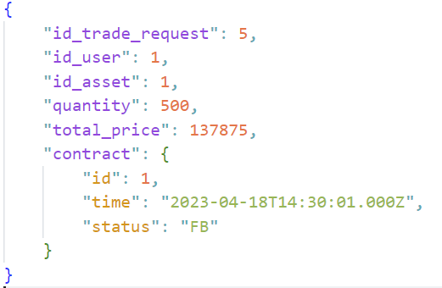

“id_trade_request” - [primary key] generated while in the PurchaseRequest table.
“id_user” – [foreign key] Corresponding data from when the request was in
SalesRequest table
“id_asset” – [foreign key] Corresponding data from when the request was in
SalesRequest table
“quantity” - Total number of assets purchased/sold, quantity 0 if it was cancelled
and no transactions took place.
“total_price” – Total value in USD of all transactions linked to this request.
“contract” – [Optional], [Embedded] Structure containing:
- [foreign key] id of the contract the trade request was bound by

time (ISODate) at which the request was rendered complete/carried out and broker's fee was charged
- status:
  - OK - fee was transferred from basic user's account to broker's
  - FB - fee not transferred error with broker's FundsTransferMethod
  - FBU - fee not transferred error with basic user's FundsTransferMethod
- fee_paid - [Optional] fee charged to user (id_user) and transferred to broker in
case of successful transaction.

3.23 carried_out_sales_request
Contains all sales trade requests that have been carried out (no longer inside SalesRequest table) as well as the information about paying the fee to the broker if the request was bound by contract.

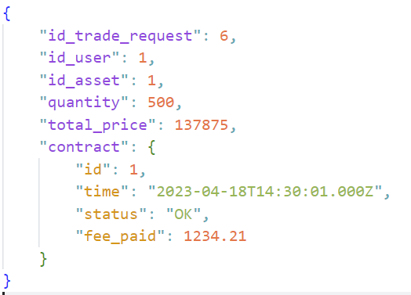

“id_trade_request” - [primary key] generated while in the SalesRequest table.
“id_user” – [foreign key] Corresponding data from when the request was in
SalesRequest table
“id_asset” – [foreign key] Corresponding data from when the request was in
SalesRequest table
“quantity” - Total number of assets purchased/sold, quantity 0 if it was cancelled
and no transactions took place.
“total_price” – Total value in USD of all transactions linked to this request.
“contract” – [Optional], [Embedded] Structure containing:
- id - [foreign key] id of the contract the trade request was bound by

time - (ISODate) at which the request was rendered complete/carried out and broker's fee was charged
- status:
  - OK - fee was transferred from basic user's account to broker's
  - FB - fee not transferred error with broker's FundsTransferMethod
  - FBU - fee not transferred error with basic user's FundsTransferMethod
- fee_paid - [Optional] fee charged to user (id_user) and transferred to broker in
case of successful transaction.

3.24 asset_transaction
It contains data about transactions that are Asset type, id_trade_request will point to the id of trade_requests that is in the ActiveTradeRequest table, and when the transaction is done, the key points to the row in the table carried_out_trade_request.

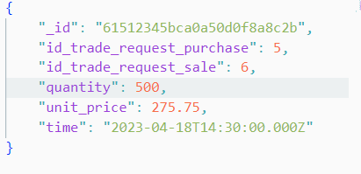

“_id” - [primary key] generated id of that transaction.

“id_trade_request_purchase” – [Optional] id of purchase request created in
PurchaseRequest table it is optional as the person
purchasing could have been someone outside our
system (for example some other real world brokerage
system)

“id_trade_request_sale” – [Optional] id of purchase request created in
SalesRequest table it is optional as the person
selling could have been someone outside our
system (for example some other real world brokerage system)

“quantity” - Total number of assets purchased/sold, quantity 0 if it was cancelled and no
transactions took place.
“unit_price” – Value of one unit of the asset purchased/sold (rounded to 2 decimals).
“time” – The exact time (ISODate) at which the transaction was successfully completed.

3.25 asset_stats
Contains additional asset data, a dynamic array that will predict asset prices.

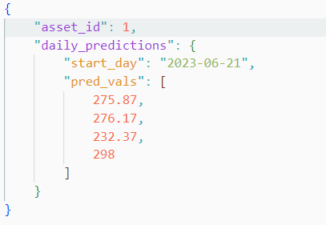

“asset_id” - [primary key] [foreign key] generated id of that asset stat.
“daily_predictions” – [Embedded] Structure containing:
- the date of the day that the predictions start at
- predicted values which are decimal prices predictions of the asset rounded to 2 decimal places

3.26 contact_support_request
Contains data from customer support messages.

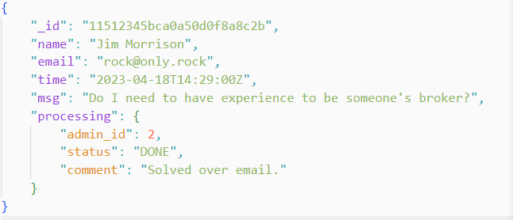

“_id” - [primary key] generated id of that contact support request.
“name” – The full name of the person that sent the support request.
“email” – The full email of the person that sent the support request.
“time” – The time (ISODate) the support request was sent.
“msg” – The message that was sent through contact form.
“processing” – [Optional] [Embedded] Structure containing:
- admin_id – [foreign key] id of admin user (table Administrator –
IdUser) who labeled the request being processed
- status – status of the request being processed:
  - DONE: done processing,
  - PENDING: still being procesed, for further info contact
admin user (admin_id)
“comment” - [Optional] comment left by the admin user (admin_id), independent of
status

